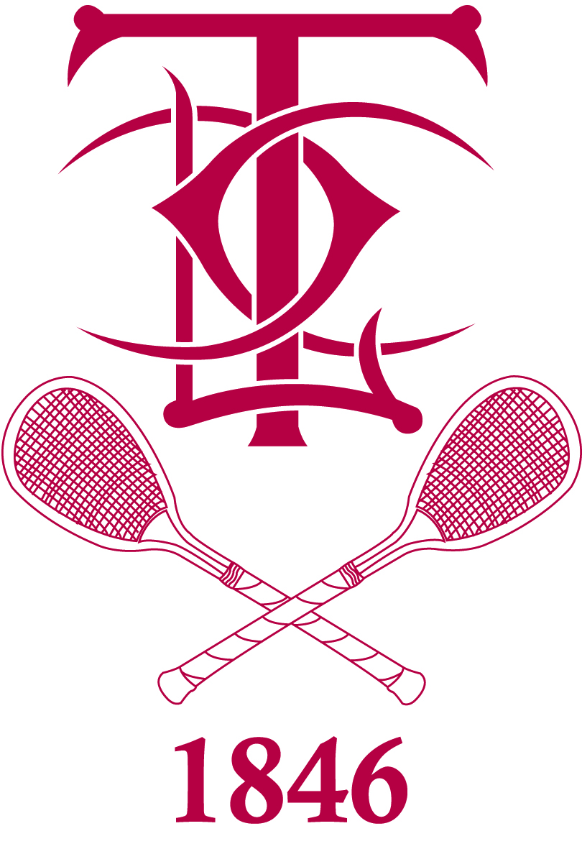

OVER 70’S HANDICAP DOUBLES
6th/7th November 2024

The Over 70s Handicap Doubles tournament will take place on Wednesday 6th & Thursday 7th November 2024, at Leamington Tennis Court Club.

It is open to ALL amateur players who are above 70 years of age as on the 6th of November 2024. Entries are limited to 12 pairs and will be awarded on a first come-first served basis.

The tournament will consist of three boxes, to be played in a round-robin format. Winners and runners-up of boxes will go through to the knockout stages, along with the 2 two ‘best losers’. Players will be ranked by handicap and put into groups with those closest to their own handicap.
Please note: An oversized frame is NOT permitted for the tournament.
Play will start at 11am on Wednesday so you need to be available in order to get the required matches in.

The entry fee is £65 per person which includes all tennis and marking, lunch on Wednesday and Thursday. A tournament dinner consisting of a three-course meal on Wednesday evening is optional at £33.50 per head, with a minimum of 12 players required to take place, plus tea and coffee throughout both days.

Please return your entry by 28th October 2024 either by post or email, attaching a cheque made payable to: LTCC
If you would like to pay via BACS, please ask for the details.
If you have any problems please contact Lewis Williams at the club using the details below.
----------------------------------------------------------------------------------------------------------

To: Lewis Williams, Leamington Tennis Court Club,
50 Bedford St., Leamington Spa, Warks CV32 5DT.
Tel: 01926 424977 e-mail: tenniscourtclub@hotmail.com

Player 1 Player 2

Name: ………………………….. Name: …………………………..

Tel: ………………………….. Tel: …………………………..

Email: ………………………….. Email: …………………………..

Handicap: ………………………….. Handicap: …………………………..
Dinner: YES/NO Dinner: YES/NO

