Paris Court Tennis Needs Our Help

Our friends at the Société Sportive du Jeu de Paume et de Racquets (the court tennis court in Paris) have the opportunity to purchase, from the current owners, the three floors in its building that house the court tennis court and club. The price is €3.8 million.

The Paris Club, located at 74 rue Lauriston in Paris, is housed in a historic 1908 building, has one court tennis court, four singles squash courts as well as social spaces and locker rooms. It has 300 members.

So far over half of the members of the Paris Club have pledged €1.1 million toward acquiring the Club’s facilities. All of the Paris members will contribute by the funding deadline which is likely to be early in the fourth quarter of 2024. More work is being done in France to garner additional support from the remaining Club members, the governing bodies for lawn tennis and squash, and French court tennis players in Fontainebleau, Bordeaux and Pau. Court tennis players in England and Australia are also being approached to obtain further support.

An acquisition of the real estate that houses the Club will ensure the game of court tennis remains in this iconic court in central Paris.

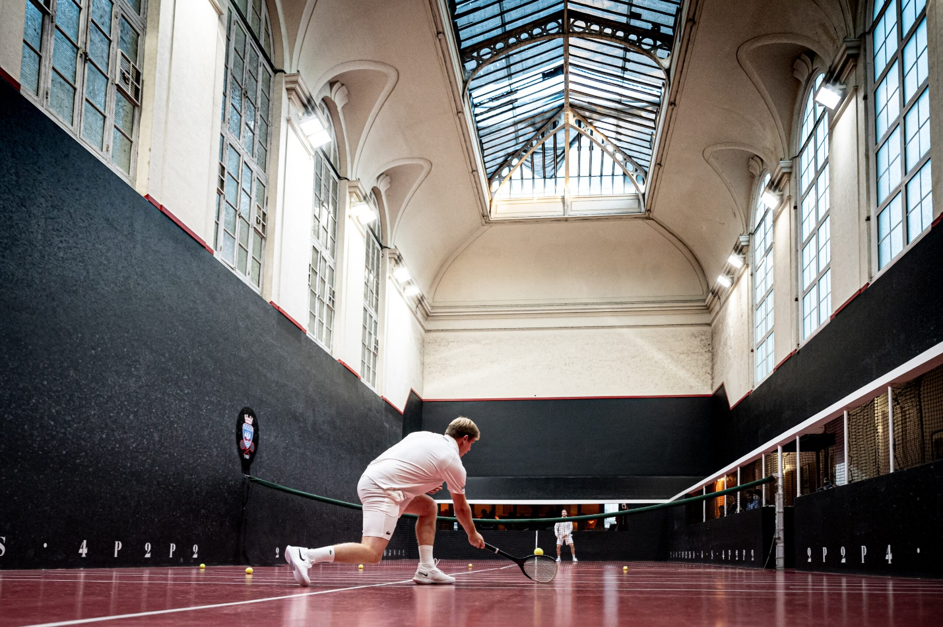

The Club has devised three ways to support preserving court tennis in Paris on rue Lauriston.

- Social Overseas Life Membership Initiative – a one-time contribution of €5,000. This membership grants lifetime access to the Club including ten court fees per year.

- Contribution. Contributions to the acquisition fund can be made in any amount. Contributions will not be tax-deductible for US taxpayers.

- Share Acquisition. Investment opportunities may be available for qualified investors.

Please click on the link below to be directed to the Paris Club’s website for instructions on how to subscribe to the Social Overseas Life Membership Initiative.

https://buy.stripe.com/cN2g2S8Ka7mhaWc8wx

As per Contribution and Share Acquisition, the funds will be asked later this year once we secure the transaction. Funds will be returned otherwise.
It is possible though to pledge right an amount now by filling out this questionnaire.

The Paris Club may be able to secure a loan for a portion of the acquisition price. However, the larger the loan, the higher the debt service costs, so raising additional equity capital through one of the three mechanisms above is critical to ensuring the long-term viability of the Club and court.

A Plea from the Paris Club

“The Société Sportive du Jeu de Paume et de Racquets is at a pivotal crossroads. With the Social Life Membership initiative and the opportunity to make a contribution, we can transform a potential crisis into a future of stability and growth. Please join us, together with all the actual players of the Club, in this crucial endeavor and help keep the spirit and tradition of our Club alive. Your support is essential in preserving the rich history of jeu de paume and squash in Paris. You can pledge today here to become a Life Social Member or contributor today, and be part of this historic legacy.”

Any and all contributions are encouraged and welcome.

Questions? Please contact Ivan Semenoff, President, at jeudepaumesquash@gmail.com or Gwénaël Moy, General Secretary, at gwenaelmoy@gmail.com

